**Megadott állapotokat bejáró szinkron sorrendi hálózat   
idődiagramjának szerkesztése (MINTA)**

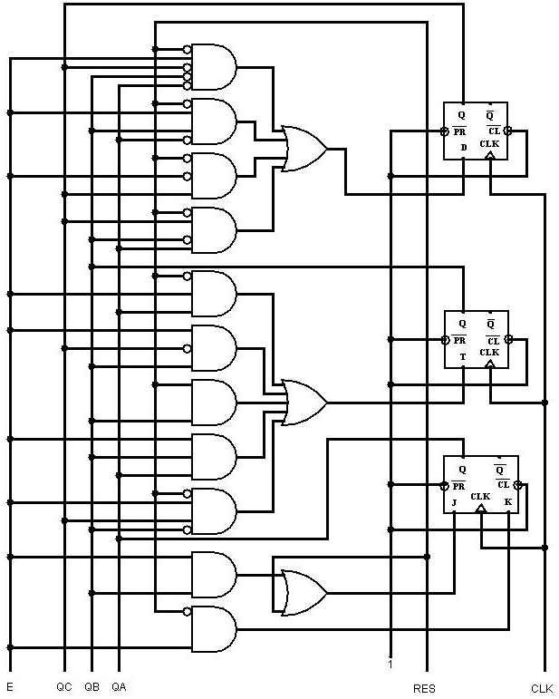Adott az alábbi kapcsolás.

Készítse el a kapcsolás idődiagramját!

**Visszafejtés:**

**Flip-flop-ok bemeneteinek vezérlő függvényei:**

$$D_{c}=\overline{R}*E*\overline{QC}*\overline{QB}*\overline{QA}+\overline{R}*E*QB*\overline{QA}+\overline{R}*\overline{E}*QC+\overline{R}*QC*\overline{QB}*QA$$

$$T_{B}=\overline{R}*E*QA+E*\overline{QC}*QB+R*QB+E*QB*QA+\overline{R}*E*QC*\overline{QB}$$

$$J_{A}=R+E*QB$$

$$K_{A}=\overline{R}*E$$

R=1 esetén:

$$D_{c}=0$$

$$T_{B}=E*\overline{QC}*QB+QB+E*QB*QA=QB*\left(E*\overline{QC}+1+E*QA\right)=QB$$

$$J_{A}=1+E*QB=1$$

$$K_{A}=0$$

A hálózat szinkron kezdőérték beállítással rendelkezik.

RESET hatására 1-be lép a hálózat

|  |  |  |  |  |  |  |  |  |
| --- | --- | --- | --- | --- | --- | --- | --- | --- |
|  | DC | TB | JA | KA | QC | QB | QA |  |
| RES | 0 | $$QB$$ | 1 | 0 | 0 | 0 | 1 | 1 |
|  | Ha QB=1, akkor TB=1, vagyis negál, ha QB=0, akkor TB=0, vagyis tart. | | | | | | | |

R=0 és E=0 esetén:

$$D_{c}=QC$$

$T_{B}=0$, tartás

$$J_{A}=0$$

$K_{A}=0$, tartás

R=0 és E=1 esetén:

$$D_{c}=\overline{QC}*\overline{QB}*\overline{QA}+QB*\overline{QA}+QC*\overline{QB}*QA$$

$$T_{B}=QA+\overline{QC}*QB+QB*QA+QC*\overline{QB}$$

$$J_{A}=QB$$

$$K_{A}=1$$

|  |  |  |  |  |  |  |  |  |  |  |  |
| --- | --- | --- | --- | --- | --- | --- | --- | --- | --- | --- | --- |
| n. állapot | | | | flip-flop-ok bemenetei | | | | n+1. állapot | | | |
|  | QC | QB | QA | DC | TB | JA | KA | QC | QB | QA |  |
| RES → 1h | 0 | 0 | 1 | 0 | 1 | 0 | 1 | 0 | 1 | 0 | 2h |
| 2h | 0 | 1 | 0 | 1 | 1 | 1 | 1 | 1 | 0 | 1 | 5h |
| 5h | 1 | 0 | 1 | 1 | 1 | 0 | 1 | 1 | 1 | 0 | 6h |
| 6h | 1 | 1 | 0 | 1 | 0 | 1 | 1 | 1 | 1 | 1 | 7h |
| 7h | 1 | 1 | 1 | 0 | 1 | 1 | 1 | 0 | 0 | 0 | 0h |
| 0h | 0 | 0 | 0 | 1 | 0 | 0 | 1 | 1 | 0 | 0 | 4h |
| 4h | 1 | 0 | 0 | 0 | 1 | 0 | 1 | 0 | 1 | 0 | 2h |

Bejárt állapotok:

RES → 1h, 2h, 5h, 6h, 7h, 0h, 4h és újra 2h

**Idődiagram:**

|  |  |  |  |  |  |  |  |  |  |  |  |  |  |  |  |  |  |  |  |  |  |  |  |  |  |  |  |  |  |  |  |  |  |  |  |  |  |  |  |  |  |
| --- | --- | --- | --- | --- | --- | --- | --- | --- | --- | --- | --- | --- | --- | --- | --- | --- | --- | --- | --- | --- | --- | --- | --- | --- | --- | --- | --- | --- | --- | --- | --- | --- | --- | --- | --- | --- | --- | --- | --- | --- | --- |
| **CLK** | |  |  |  |  |  |  |  |  |  |  |  |  |  |  |  |  |  |  |  |  |  |  |  |  |  |  |  |  |  |  |  |  |  |  |  |  |  |  |  |  |
|  |  |  |  |  |  |  |  |  |  |  |  |  |  |  |  |  |  |  |  |  |  |  |  |  |  |  |  |  |  |  |  |  |  |  |  |  |  |  |  |  |  |
| **RES** | |  |  |  |  |  |  |  |  |  |  |  |  |  |  |  |  |  |  |  |  |  |  |  |  |  |  |  |  |  |  |  |  |  |  |  |  |  |  |  |  |
|  |  |  |  |  |  |  |  |  |  |  |  |  |  |  |  |  |  |  |  |  |  |  |  |  |  |  |  |  |  |  |  |  |  |  |  |  |  |  |  |  |  |
| **E** | |  |  |  |  |  |  |  |  |  |  |  |  |  |  |  |  |  |  |  |  |  |  |  |  |  |  |  |  |  |  |  |  |  |  |  |  |  |  |  |  |
|  |  |  |  |  |  |  |  |  |  |  |  |  |  |  |  |  |  |  |  |  |  |  |  |  |  |  |  |  |  |  |  |  |  |  |  |  |  |  |  |  |  |
| **QC** | |  |  |  |  |  |  |  |  |  |  |  |  |  |  |  |  |  |  |  |  |  |  |  |  |  |  |  |  |  |  |  |  |  |  |  |  |  |  |  |  |
|  |  |  |  |  |  |  |  |  |  |  |  |  |  |  |  |  |  |  |  |  |  |  |  |  |  |  |  |  |  |  |  |  |  |  |  |  |  |  |  |  |  |
| **QB** | |  |  |  |  |  |  |  |  |  |  |  |  |  |  |  |  |  |  |  |  |  |  |  |  |  |  |  |  |  |  |  |  |  |  |  |  |  |  |  |  |
|  |  |  |  |  |  |  |  |  |  |  |  |  |  |  |  |  |  |  |  |  |  |  |  |  |  |  |  |  |  |  |  |  |  |  |  |  |  |  |  |  |  |
| **QA** | |  |  |  |  |  |  |  |  |  |  |  |  |  |  |  |  |  |  |  |  |  |  |  |  |  |  |  |  |  |  |  |  |  |  |  |  |  |  |  |  |
|  |  |  |  |  |  |  |  |  |  |  |  |  |  |  |  |  |  |  |  |  |  |  |  |  |  |  |  |  |  |  |  |  |  |  |  |  |  |  |  |  |  |
| **DC** | |  |  |  |  |  |  |  |  |  |  |  |  |  |  |  |  |  |  |  |  |  |  |  |  |  |  |  |  |  |  |  |  |  |  |  |  |  |  |  |  |
|  |  |  |  |  |  |  |  |  |  |  |  |  |  |  |  |  |  |  |  |  |  |  |  |  |  |  |  |  |  |  |  |  |  |  |  |  |  |  |  |  |  |
| **TB** | |  |  |  |  |  |  |  |  |  |  |  |  |  |  |  |  |  |  |  |  |  |  |  |  |  |  |  |  |  |  |  |  |  |  |  |  |  |  |  |  |
|  |  |  |  |  |  |  |  |  |  |  |  |  |  |  |  |  |  |  |  |  |  |  |  |  |  |  |  |  |  |  |  |  |  |  |  |  |  |  |  |  |  |
| **JA** | |  |  |  |  |  |  |  |  |  |  |  |  |  |  |  |  |  |  |  |  |  |  |  |  |  |  |  |  |  |  |  |  |  |  |  |  |  |  |  |  |
|  |  |  |  |  |  |  |  |  |  |  |  |  |  |  |  |  |  |  |  |  |  |  |  |  |  |  |  |  |  |  |  |  |  |  |  |  |  |  |  |  |  |
| **KA** | |  |  |  |  |  |  |  |  |  |  |  |  |  |  |  |  |  |  |  |  |  |  |  |  |  |  |  |  |  |  |  |  |  |  |  |  |  |  |  |  |
|  |  |  |  |  |  |  |  |  |  |  |  |  |  |  |  |  |  |  |  |  |  |  |  |  |  |  |  |  |  |  |  |  |  |  |  |  |  |  |  |  |  |